WEB PHISHING DETECTI0N

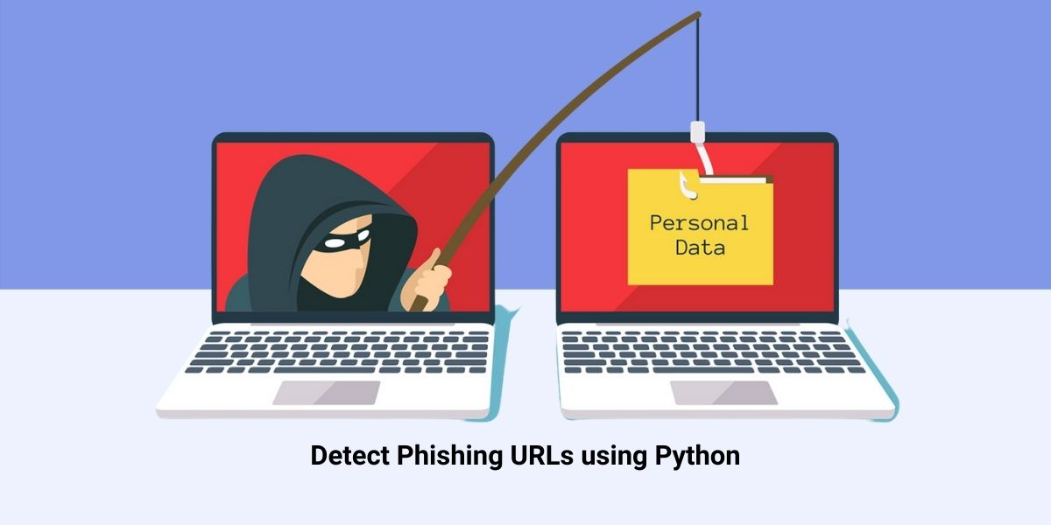*LITERATURE SURVEY*

*TEAM DETAILS*

*TEAM NUMBER : PNT2022TMID34399*

*COLLEGE NAME : CAPE INSTITUTE OF TECHNOLOGY*

*DEPARTMENT : INFORMATION TECHNOLOGY*

TEAM MEMBERS

|  |  |
| --- | --- |
| TEAM MEMBER POSITION | MEMBER NAME |
| TEAM LEADER | A.ISWARYA |
| TEAM MEMBER 1 | T.PARVATHY |
| TEAM MEMBER 2 | T.SALINI |
| TEAM MEMBER 3 | A.SAHAYA ABISHA |



LITERATURE SURVEY

|  |  |
| --- | --- |
| DATE | 19/10/22 |
| PROJECT NAME | WEB PHISHING DETECTION |

LITERATURE SURVEY

According to this paper we people are highly dependent on the internet. For performing online shopping and online activities like banking, mobile recharge and more activities are done only through internet. Here phishing is nothing but a type of website threat which illegally collects the original website information such as login id, password and credit card information. Here we will use an efficient machine learning based web phishing detection technique

Problem Identification

There are many users who purchase products through online platform and the payment is done through e-banking

There are some fake banking websites in which they collect the more sensitive information like username, password, credit card details etc , for illegal purpose. This type of websites are called phishing website. Here web phishing is one of the security threat to webservices on the internet

Problem Solution

To overcome the problem of phishing website whenever we are clicking on one website it must show an alert box like it is a secure website or it is not a secure website.Then another way is that we can scan the website in order to prevent our system or mobile from the phishing attack. Even though technologies are there we as the user have to be aware of the websites whether it is secure or not. We should not click any unwanted websites.

REFERENCES

[1] Higashino, M., et al. An Anti-phishing Training System for Security Awareness and Education Considering Prevention of Information Leakage. in 2019 5th International Conference on Information Management (ICIM). 2019.

[2] H. Bleau, Global Fraud and Cybercrime Forecast,. 2017.

[3] Michel Lange, V., et al., Planning and production of grammatical and lexical verbs in multi-word messages. PloS one, 2017. 12(11): p. e0186685-e018668

CONCLUSION

This paper aims to enhance detection method to detect phishing website using machine learning technology.

Also , classifiers generated by machine learning algorithms identify legitimate phishing websites.

The proposed technique can detect new temporary phishing sites and reduce the damage caused by phishing attacks.

The performance of the proposed technique based on machine learning is more effective that previous phishing detection technologies.

In the future, it will be useful to investigate the impact of feature selection using various algorithms

